Societal Costs of Abortion

By James R. Harden, M.Div., Reginald Finger, MD, MPH
and the CompassCare analysis team, Rochester, NY

On the surface, some might think abortion saves money. Initially, this assumption seems especially sensible to those of us who have served in health departments and social service agencies. We see a young, single, pregnant girl in the clinic and we think about what it will cost for her to parent the child rather than abort. In keeping the baby, she will face medical bills, housing and basic living costs, delay in educational plans, and the list goes on.

We then show the young woman an ultrasound picture of her developing baby and make our case for life mostly by emphasizing that the life inside her is a BABY, and that abortion destroys a baby, and that having an abortion will also harm the mother both physically and emotionally, in the long and the short term. Then we take a deep breath and we say to her, "Oh boy, we know it’s going to cost a whole lot to do this, but we will stand with you and give you all the help we can."

We would be wrong to ignore the financial burden. However, as we shall see, we need not concede the financial side of the argument to the pro-abortion forces. A liveborn infant is a new person – one who will eventually work, contribute to society and pay taxes. As we have discussed in another report, abortion has contributed to a serious shortage of people to do all the producing, inventing, buying and caring that needs to be done. In this article, we show that, from the viewpoint of the society at large, a typical person’s eventual economic output dwarfs the costs paid to bear and raise him. This fact is true both for total costs and for costs paid by public funding sources.

In the following chart we compare the societal costs resulting from aborting an unborn child to those that result from giving birth. The unit of analysis here is one person; the impact of women’s collective decisions at the county, state or national level would be these numbers multiplied thousands of times. Four categories of cost and one category of benefit – that of one person’s eventual economic productivity – are calculated and compared. Chart 1 tabulates all the costs, regardless of who pays them. Chart 2 shows those that are paid by (or saved by) the “public purse.” The public costs divided by the total are called the “public cost fraction.”

The first cost category is that of abortion itself. According to the National Abortion Federation (www.prochoice.org) and the Alan Guttmacher Institute (www.agi-usa.org), the average cost of an abortion up to 10 weeks pregnancy is $527. At 16 weeks it increases to $738, and beyond 20 weeks it rises to $1,370. Taking a weighted average of these costs by the national frequency of abortion by gestational age, the mean cost of an abortion is $583. In chart 2, 14 percent of this figure is entered as the public cost of abortion, based on an AGI estimate that 14 percent of abortions are paid for by Medicaid funds.

The second category in this analysis is breast cancer (based on research findings showing an increased risk of breast cancer in those women undergoing abortion, compared to those carrying the pregnancy to full term). Because this study concerns women already pregnant, there is no need to address the more controversial question of whether abortion is an independent risk factor for breast cancer. The relative risk of 1.38 is derived from Brind’s 1996 meta-analysis and the lifetime risk of breast cancer for women not experiencing abortion is .107 – calculated from a figure of one in eight lifetime for all women and from the relative risk. The $46,750 average treatment cost of breast cancer is from Polsky et al., and 43 percent is estimated as the public cost fraction based on the approximate percentage of breast cancer patients who are eligible for Medicare.
Relative risk is the probability of an outcome (in this case, breast cancer) in people with a risk factor (in this case, abortion) divided by the probability of that same outcome in people without the risk factor.

The third category is subsequent premature births. Women undergoing abortion remain at increased risk both for extreme prematurity (delivery at 32 weeks or less) and for delivery between 33 and 36 weeks for the remainder of their reproductive lifetimes. Costs associated with these outcomes are multiplied by their probabilities, and also multiplied by two to take into account the fact that the average woman in America today gives birth to two children during her lifetime. Births at less than 32 weeks have a small but measurably increased risk of cerebral palsy, a very expensive outcome. To be conservative with the cost estimates, other specific adverse outcomes were not tabulated separately. Lifetime medical costs for a premature infant as well as delivery / initial hospital stay costs are listed. Because approximately one-third of these infants are covered by Medicaid 0.333 is listed as the public cost fraction for all the prematurity outcomes.

The last two cost categories dwarf the others. To be fair, we have estimated generously for the opportunity cost of raising a child, since this cost of “choosing life” partially offsets the lifetime societal benefit provided by that person over her lifespan. Phillip Longman has estimated the opportunity costs from birth to age 17 and divided them into four categories. For the largest category – foregone wages – Longman assumes for the purpose of modeling that the birth of a child results in one parent quitting work for five years and then returning part-time for the subsequent 12 years. For the public cost fraction for foregone wages, we calculated from the 2004 federal tax table the income and social security tax that would have been paid on those wages. For housing, we included the cost that one extra bedroom adds to a standard U.S. military housing allowance. For food and other costs, we based the figure on what one additional child adds to the maximal benefit amounts for TANF and food stamps in the Colorado public assistance system.

We based our conservative estimates of the lifetime productivity of one person on the median per capita income from the U.S. Census Bureau, incremented for inflation at 3 percent per year from 2004. The fraction tabulated as a benefit to the public treasury is the income and social security tax that person would pay based on the 2004 federal tax table. We assumed that the individual enters the work force at 18, marries at 22 and has two children, five and eight years following marriage. This model assumes an individual who does not pursue a college education. To alter the model for a college-educated individual, one might increase the opportunity costs by about $200,000 to cover college expenses and lost earnings during the college years, but increase the ultimate lifetime earning potential by perhaps $500,000 to account for the benefits of the college degree.

The bottom line for the society, per person, comes out to roughly a $1.4 million benefit for a child allowed to be born, contrasted with a cost of just under $100,000 for an aborted child. To the public treasury, the estimated benefit of the birth is just over $200,000, compared to an abortion cost of $32,000. The figures in the second chart are perhaps the more relevant for public policy, because they are clearly borne by the public instead of by the individual or family.

Returning to our clinic setting, in many cases it will still be a hardship for a young woman to choose life for her infant. But at least we can assure her that when she does, she will not, as some might suggest to her, be creating a net financial liability to society. For more information or questions about this article, contact Dr. Reginald Finger @ fingerrf@msn.com.

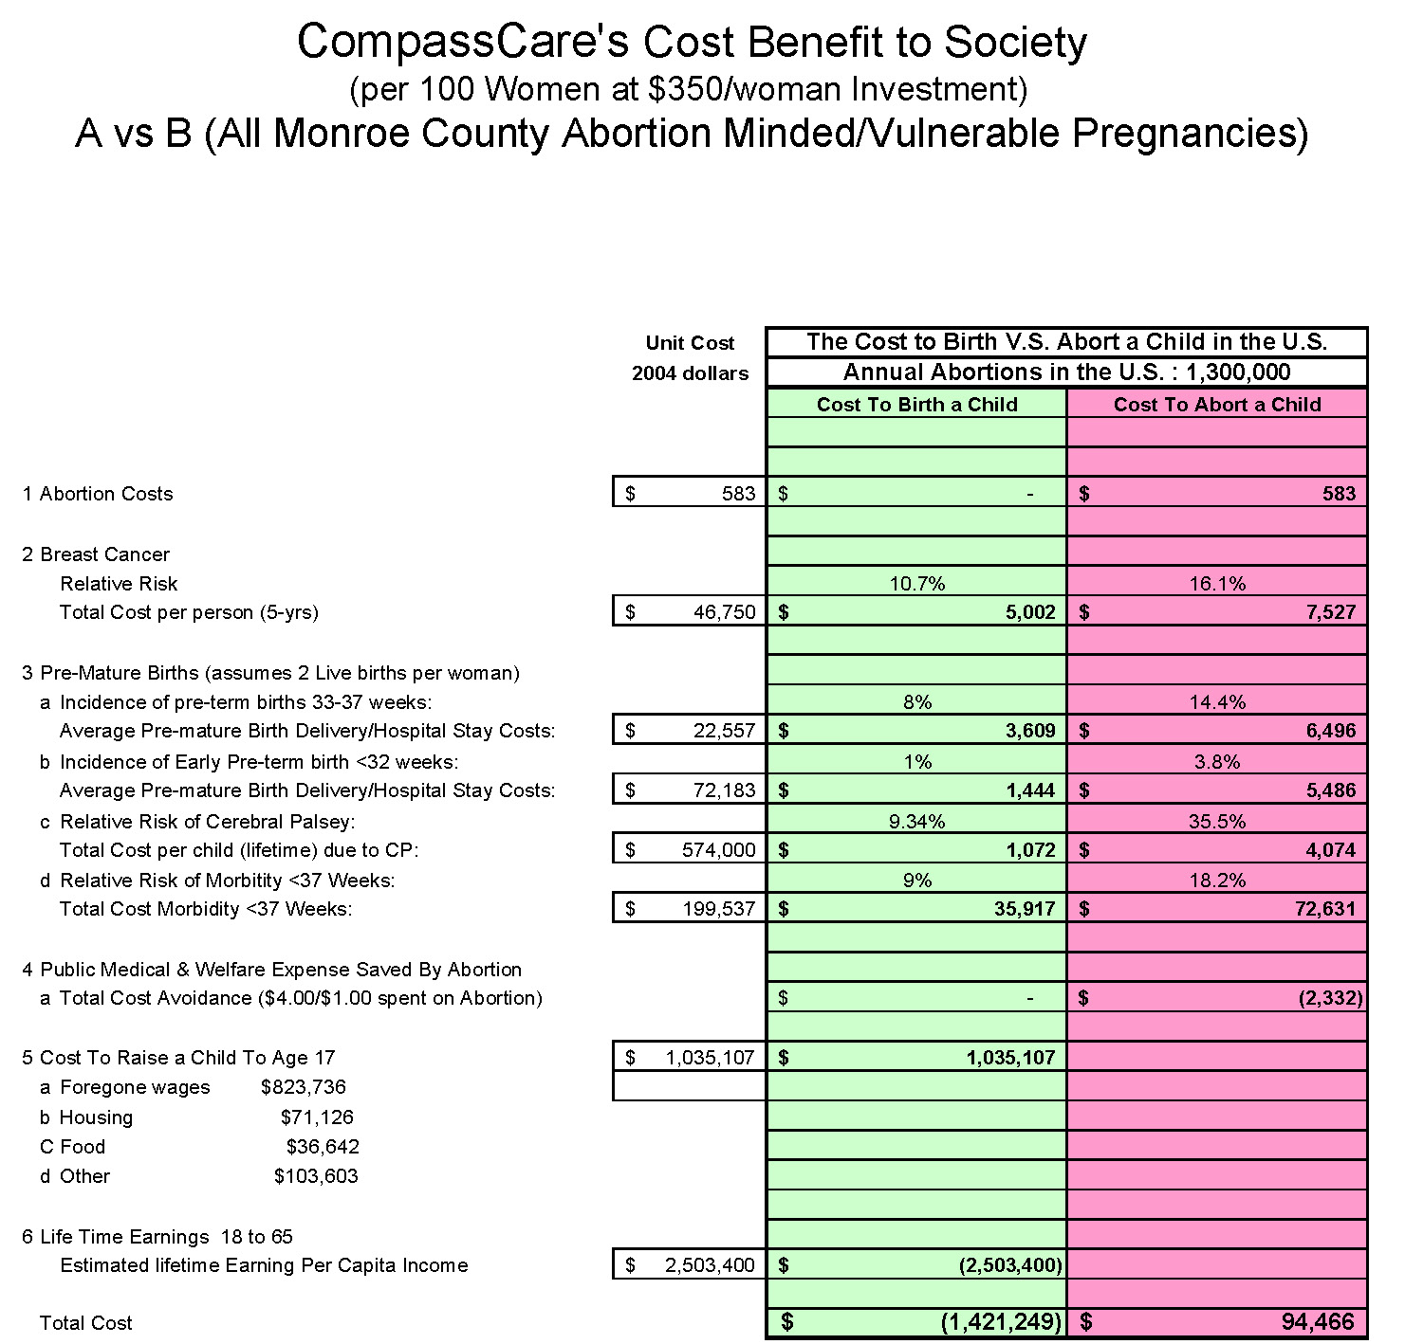

Reginald Finger, "Human Capital – America’s Forgotten Priority," Focus on Social Issues, Worldview, September 2, 2005.
"Induced Abortion in the United States," The Alan Guttmacher Institute, May 18, 2005, http://www.guttmacher.org/pubs/fb_induced_abortion.html#32ref.
Brind, Chinchilli, Severs, Summy-Long, "Induced abortion as an independent risk factor for breast cancer: A comprehensive review and meta-analysis," Journal of Epidemiology and Community Health, 1996; 50: 481-96.
Ries, Kosary, Hankey, et al, SEER Cancer Statistics Review 1973-1996, National Cancer Institute; Sondik, Breast Cancer, "Trends: Incidence, mortality, and survival," Cancer, 1994; 74:995-999.
Polsky, Mandelblatt, Weeks, et al, "Economic evaluation of breast cancer treatment: considering the value of patient choice," Journal of Clinical Oncology, 2003 Mar 15; 21(6):1139-46.
U.S. National Cancer Institute, Surveillance, Epidemiology and End Results, 1998-2002, http://seer.cancer.gov/statfacts/html/breast.html?statfacts_page=breast.html&x=19&y=14
Rooney and Calhoun, "Induced abortion and risk of later premature births," Journal of American Physicians and Surgeons 2003; 8(2) 46-49.
"Cost of Low Birth Weight," http://www.epa.gov/oppt/coi/docs/III_2.pdf.
Waitzman, Romano, Scheffler, "Estimates of the economic costs of birth defects," Inquiry, 1994 Summer;31(2):188-205.
Sue Ricketts, Colorado Department of Public Health and Environment, personal comm., August 2005
Phillip Longman, The Empty Cradle, (New York, Basic Books, 2004), p. 73.
"Income, Poverty, and Health Insurance Coverage in the United States: 2003," http://www.census.gov/prod/2004pubs/p60-226.pdf.

